Requirement Analysis and Gathering

Universal Search Assignment

Presented by Somnath Mishra



Agenda

* Introduction
* Questions
* Assumptions
* Mockups And
* Estimation

**Introduction**

* Requirements Analysis & Gathering is the first step in a project lifecycle.
* Considered the most complex aspect of the project.
* Output of this phase form critical inputs to determine project schedules, budgets, resourcing, implementation / upgrade / development methodologies and testing strategies.
* Errors introduced in this stage are costly to fix in later stages of the project lifecycle.

**Questions**

### **Who requirements questions**

* Who will use this feature?
* Who can I ask to learn more about this?
* Who will receive the outputs of the feature?
* Who will receive the outputs of the feature?
* Who are the most important stakeholders?

### **What requirements questions**

* What do I know about this feature?
* What does this feature need to do?
* What needs to be tracked?
* What is the end result of doing this?
* What other features are dependent upon this feature?
* What needs to happen next?

### **How requirements questions**

* How will you use this feature?
* How might we meet this business need?
* How will we know this is complete?

### **Where requirements questions**

* Where does the process start?
* Where would the user access this feature?
* Where would the user be located physically when using this feature?
* Where would the results be visible?

### **When requirements questions**

* When will this feature be used?
* When do you need to know about…?
* When will the feature fail?
* When will we be ready to start?
* When does the feature HAVE to be Available?

### **Why requirements questions**

* Is there any other way to accomplish this?
* Does this feature meet the business need and solve the problem we’re trying to solve?

Assumptions

* Which type of contributors we HAVE involved?
* Deadline meet our requirement.
* Budget should be in our limit.
* What can I do, if I get less number of features?
* What happen if the customers isn’t satisfied with the solution?
* Do you have any other implementations features?
* What should I do, if I get N numbers of bugs in the solution?
* What approach should you used to complete the projects?
* There will be any training room for identified the problem that we have.
* Users get any support if they facing some error.
* Possibility of failure or loss.
* What the financial impact.

Mockups



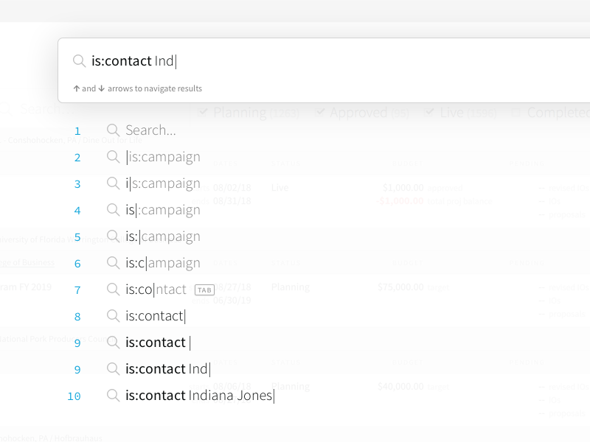

**Estimation**

* First we try to make one job description features, with suitable title, location, description, readers, contributors with date and time.
* We have to break the effort into manageable pieces.
* We’ll estimate differently if we’re using a plan-driven approach (Waterfall) than if we’re estimating in a change-driven (Agile) environment.
* How long it take to complete the project.
* Create yellow sticky notes for better understanding of the project.
* Length of audio and video and of the resolution.
* Last hour traceability matrix.